Fuel Heating Pump
In winter of plateau and cold region, it is often found that it is quite hard to start the engine due to the wax deposition in fuel, or the engine shuts down soon after the start, which brings inconvenience to users. After the intensive study of clients' demands and the properties of engine starting, Weichai Power has developed the product of "heating pump". It is the multi-functional device that combines the functions of fuel heating, wax melting, fuel pumping, exhausting and fuel filtering. It is useful device for users in cold region.
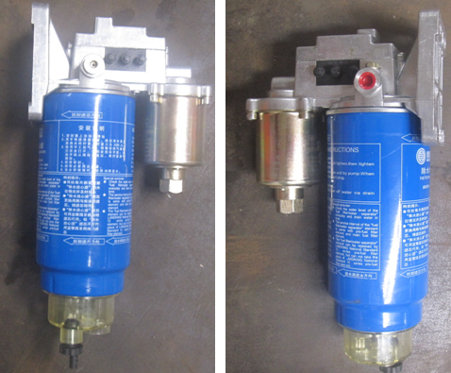
Functions | Operations | Principles
I. Pre-heat to melt wax deposition | Switch on ignition switch, if the fuel temperature is above 6 degree, the heater rod will not work, while when the temperature is lower than 6 degree, heater rod will work automatically until the fuel temperature reaches 35 degree | Heater rod is used to heat fuel and melt wax deposition. The heating process is undertaken during the fuel pumping so as to improve the liquidity of the fuel by raising the temperature of fuel. The startup of the engine will be ensured.<
II. Fuel pump and air elimination | Switch on ignition switch, the electric pump will operate for 10 minutes and then stop automatically. | The enforced fuel pump will be started to expel the air in the fuel. The time for establishing pressure will be reduced and property of start-up will be improved.
III. Fuel filter | Water-removal filter is adopted. | To filtrate water and impurities so as to reduce the failure rates of injection pumps and fuel injectors as well as fuel pipes.
7 functions of Fuel heating pump
1) The electric pump can pump fuel and expel air automatically. The operation is user-friendly;
2) When the temperature is low, the temperature-controlled heater will preheat to melt down the wax deposition and prevent fuel from freezing;
3) Heat up the fuel to ensure that vehicle may start in low temperature;
4) Auxiliary fuel supply at low temperature to ensure efficient power of vehicles.
5) Water removal filter has the efficiency of above 95%, so as to reduce the failure rate in fuel supply system.
6) Functions of expelling air and pumping fuel will reduce the failure rate of the engine;
7) Standard fuel can be used even at low temperature so as to reduce the cost of fuel.
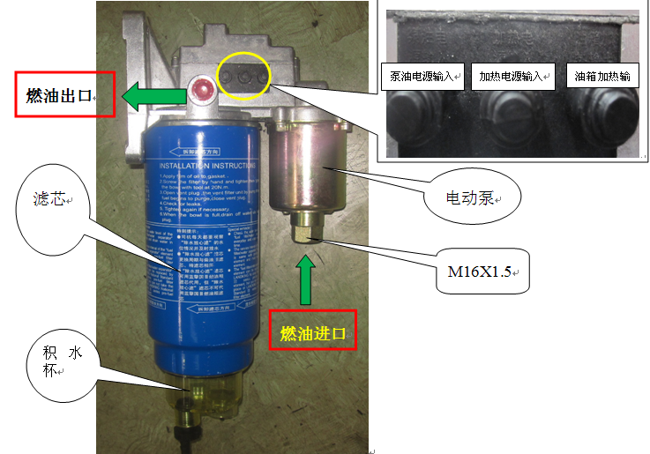
Fuel inlet
Filter cartridge
Water collection cup

Electric pump
Power supply input of fuel pump
Heating power supply input
Fuel tank heating input
Fuel inlet

Wire connections on heating pump are shown in the diagram below
Connect two wires on chassis harness (with the same wire number) to "power supply to fuel pump inlet" terminal and "power supply to heater inlet" terminal respectively. Then set the protective jacket to these terminals. Do not have the fuel tank heating terminal output connect wire.
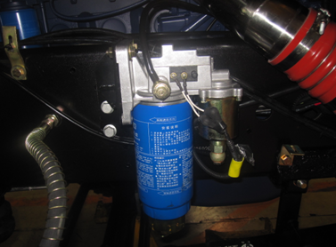
The plug-in connectors for electric fuel pump filter wire harness both on the chassis and in the cab are two-hole plug-in connector X90.
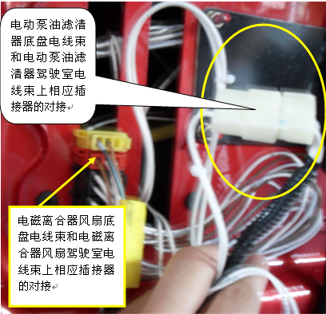
The connection of plug of the electric fuel pump filter wire harness on the chassis and the plug-in connector to the cab

The connection of wire harness on the chassis of electromagnetic clutch fan and plug-in connector to the cab

